Citi Bike Analytics

**Overview**

During April 2021, there were 553 users (unique bike ids) and 23,318 trips and on average the trip lasted 1,393 seconds (23 minutes)

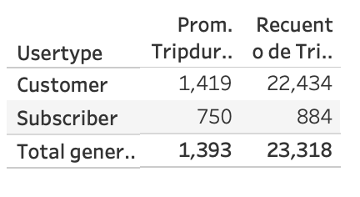

**Trips per customer**

Customers had from 1-120 trips; 7 customers (1.2%) had +100 trips, 78 (14%) customers range from 99-70 trips, 197 (35%) customers range from 69-40 trips , 153 customers range from 39-20 trips and 118 customers range from 19-1 trip

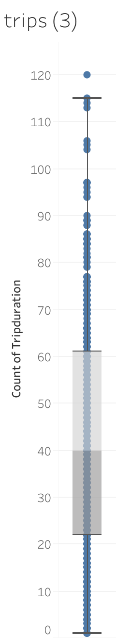

**Most use stations. (Start and end station)**

Considering star and end stations counts, which are the busiest stations during the month?

Liberty Station: 548

Newport Parkway: 370

Marin Light Rail: 221

JC Medical Center: 188

Sip Ave: 177

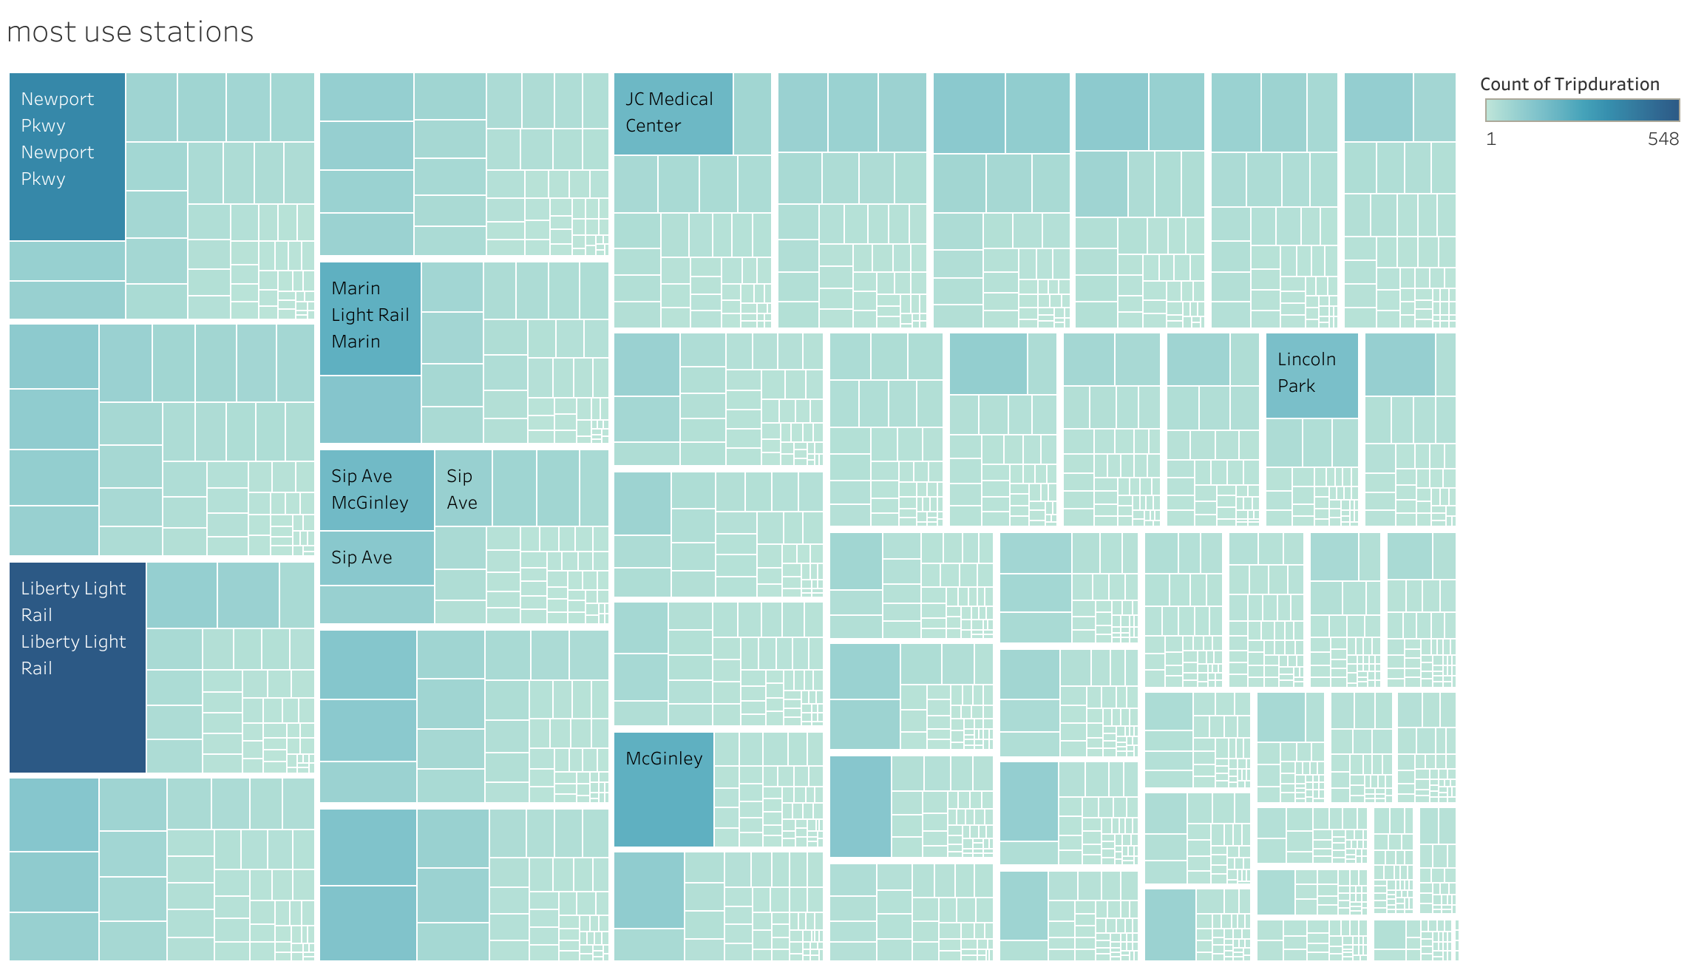

**Start and end times**

Which are the hours that have more trips?

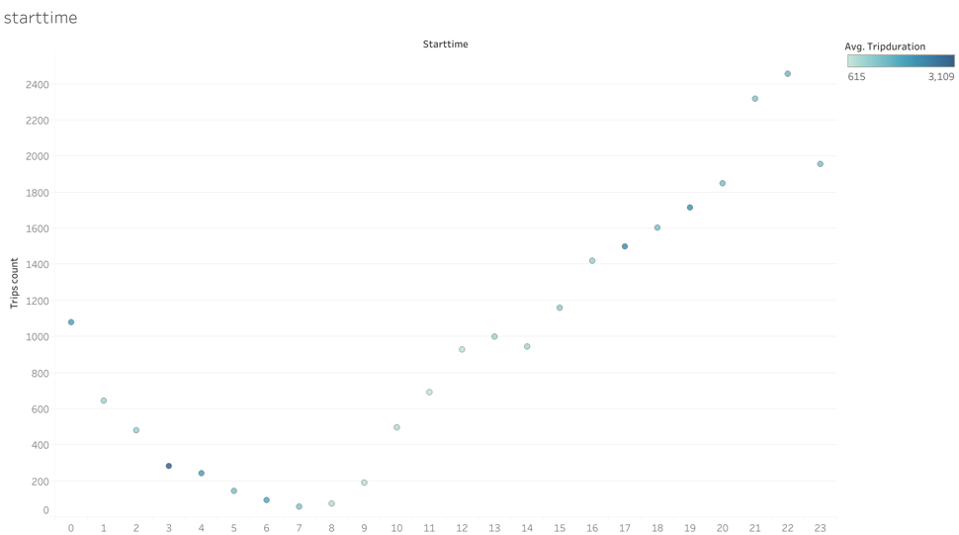

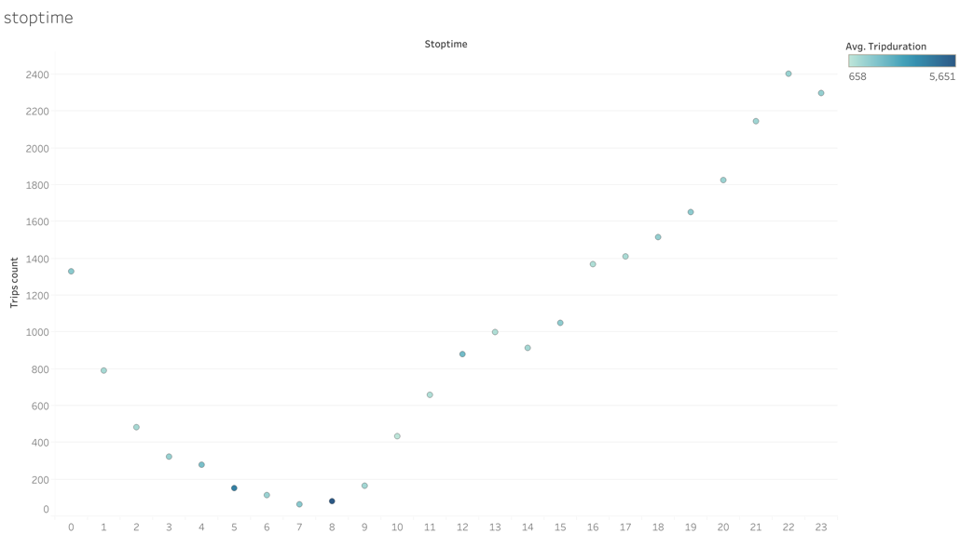

Mapping the data